Marriage Biodata Format in Word
Here is the list of all formats of biodata for marriage in English. Click on the below link to create marriage biodata in English.
englishbiodata.com

Click here to make biodata for marriage in English.
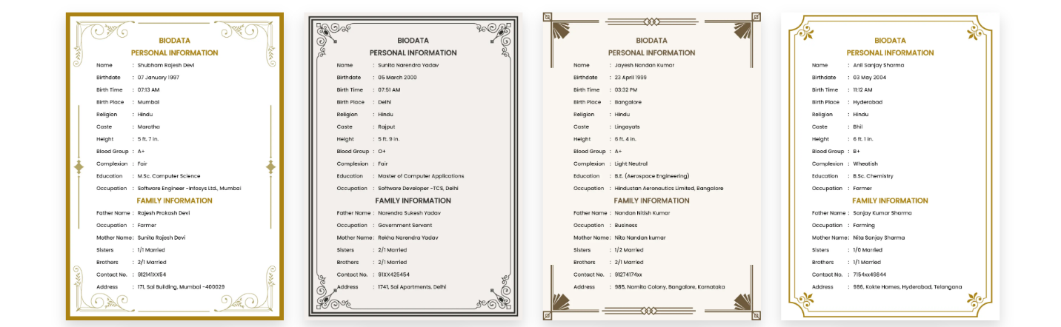
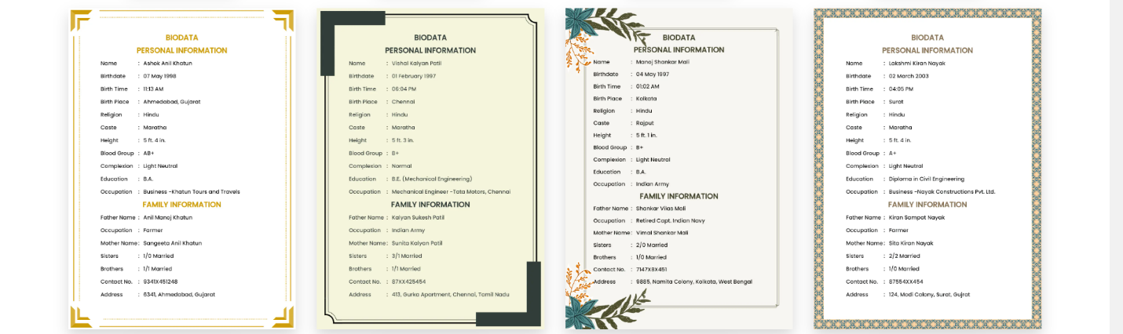
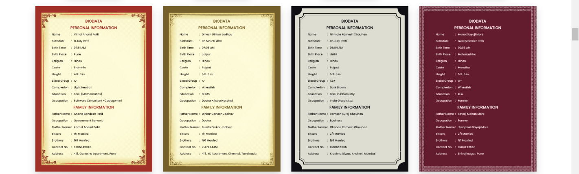

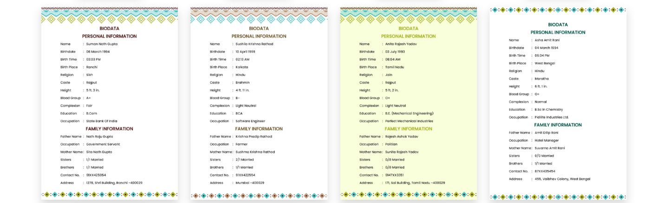
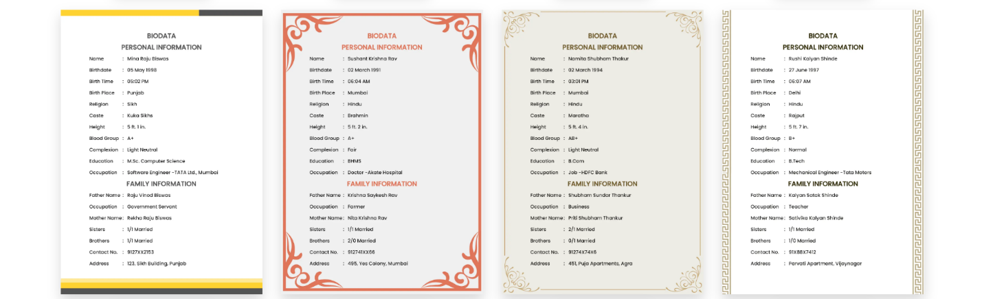
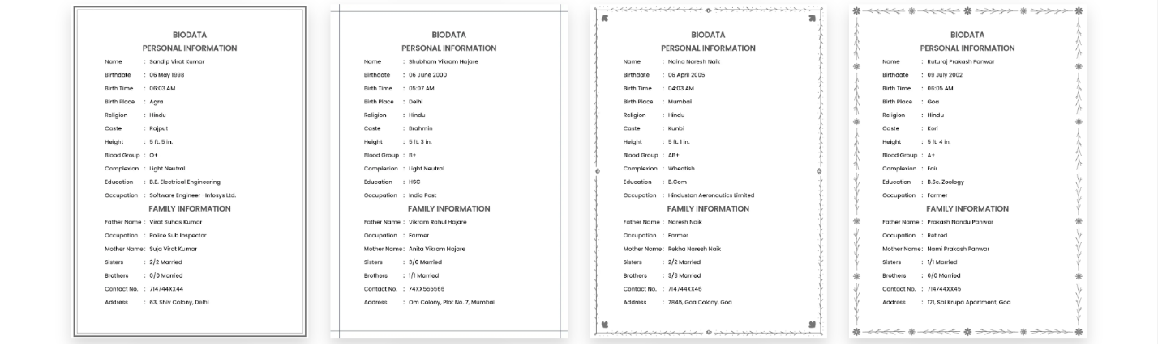
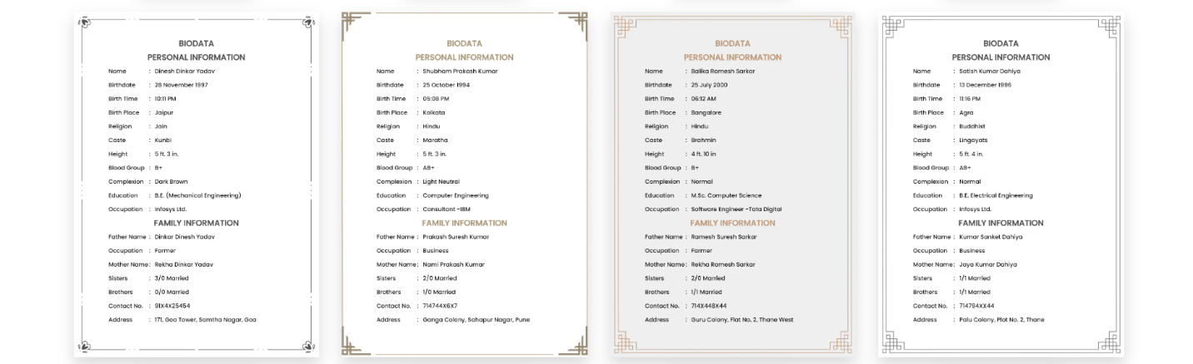

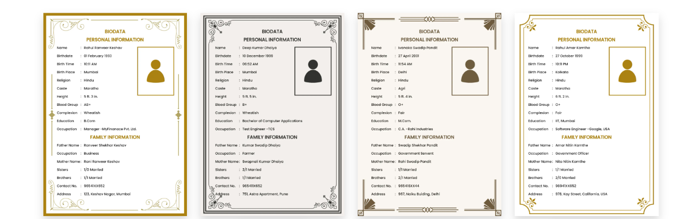
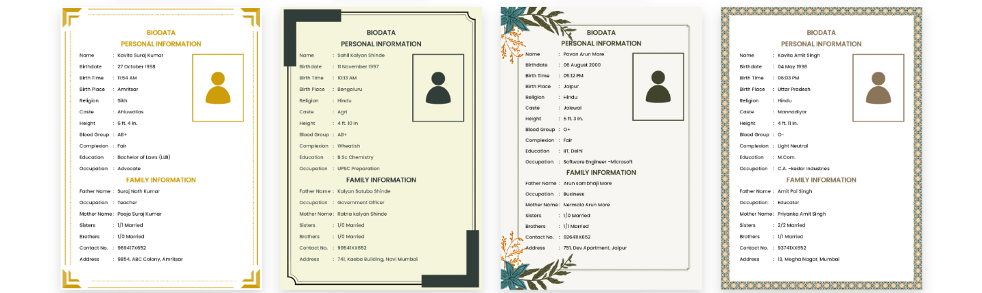
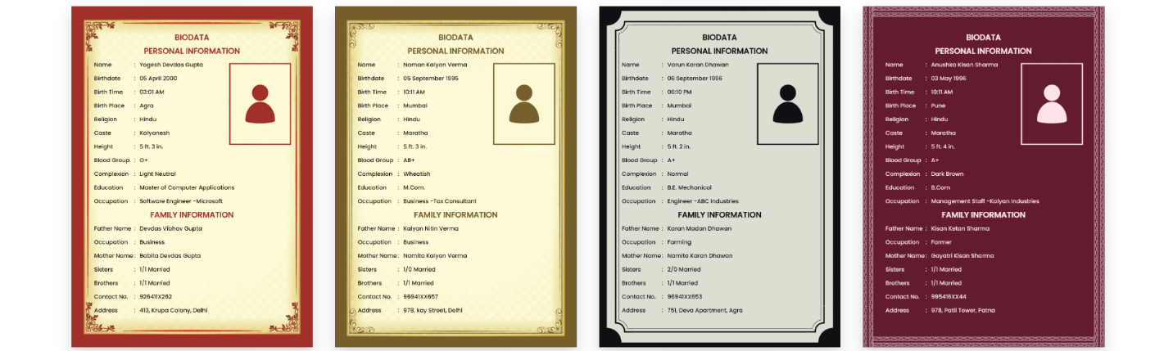
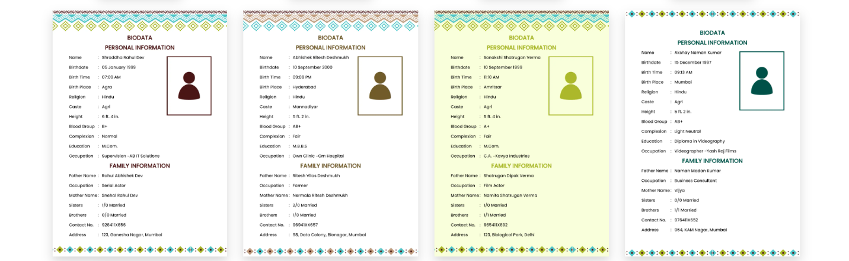
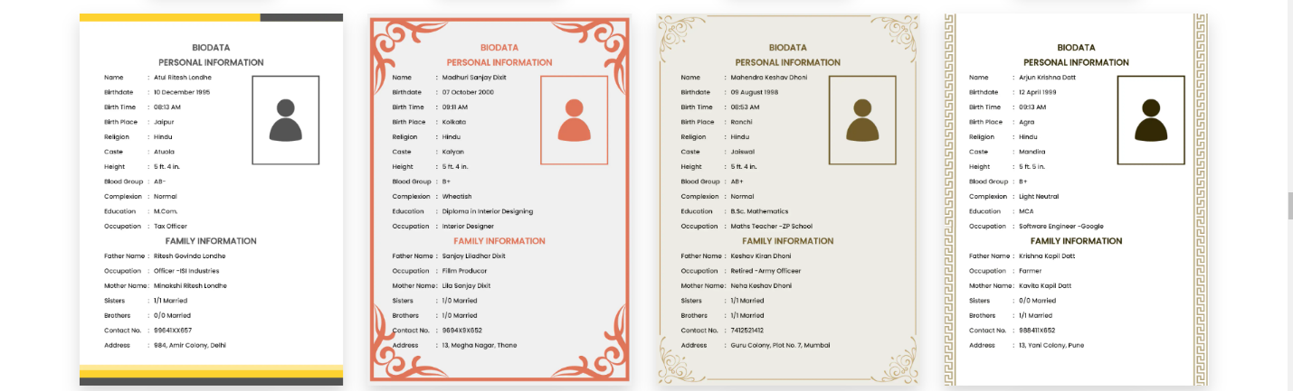
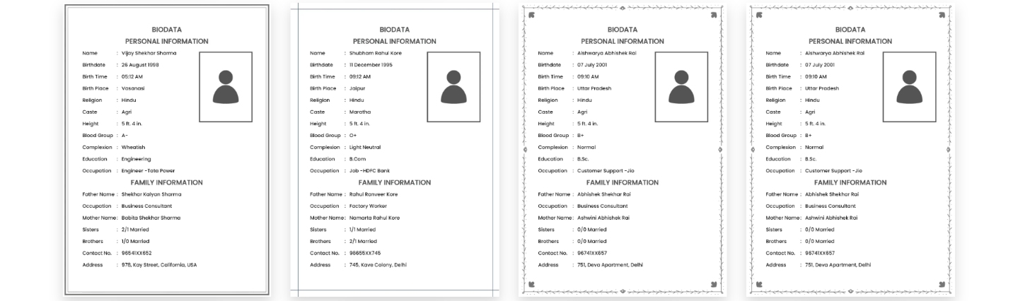
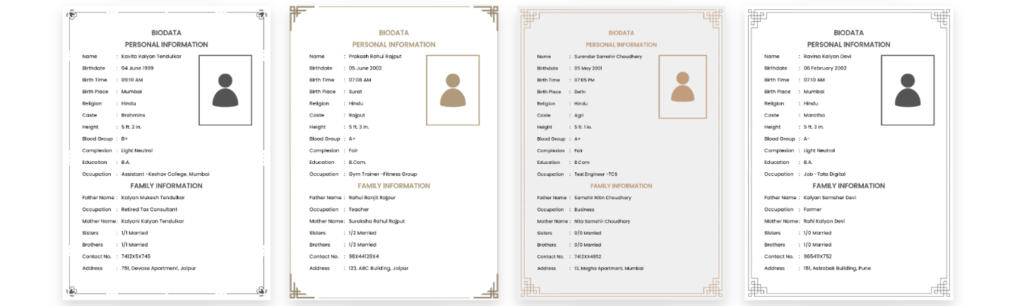

Click here to make biodata for marriage in English.

